Hypothesis Testing Solutions

# Z- test

## Example 1

The mean height from the entire of men and women in the population is 170cm. You want to check if there is a statistically significant difference (with a significance level of 95%) between the means of the sample and the population. Calculate the z-test to test is the observed data is different from the population data for

* i 10 men of height: 179, 188, 172, 185, 171, 199, 176, 188, 158, 200

##   
## One Sample t-test  
##   
## data: data  
## t = 2.8094, df = 9, p-value = 0.0204  
## alternative hypothesis: true mean is not equal to 170  
## 95 percent confidence interval:  
## 172.2595 190.9405  
## sample estimates:  
## mean of x   
## 181.6

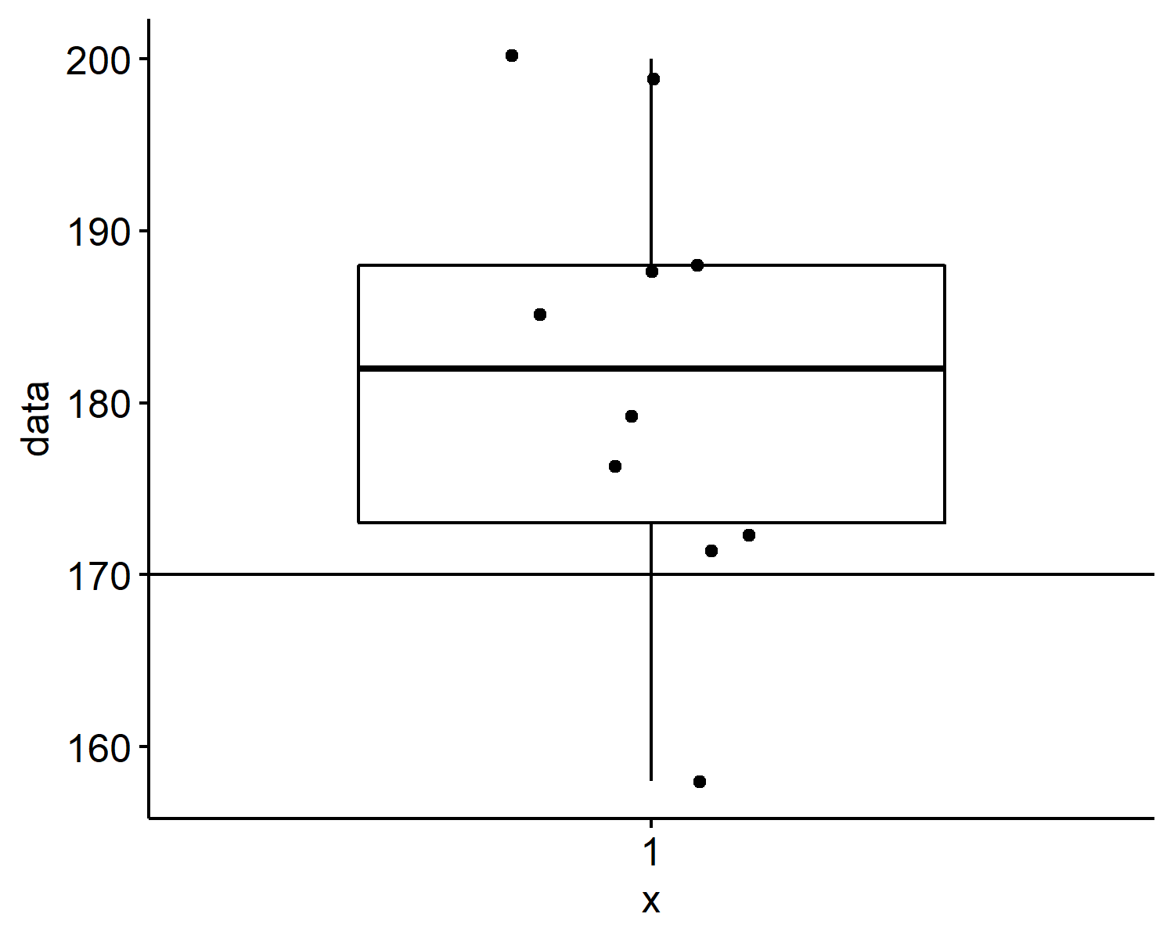

* ii 12 women of height: 175, 158, 159, 167, 171, 151, 160, 167, 147, 172, 154, 152

##   
## One Sample t-test  
##   
## data: data  
## t = -3.3613, df = 11, p-value = 0.00635  
## alternative hypothesis: true mean is not equal to 170  
## 95 percent confidence interval:  
## 155.2446 166.9221  
## sample estimates:  
## mean of x   
## 161.0833

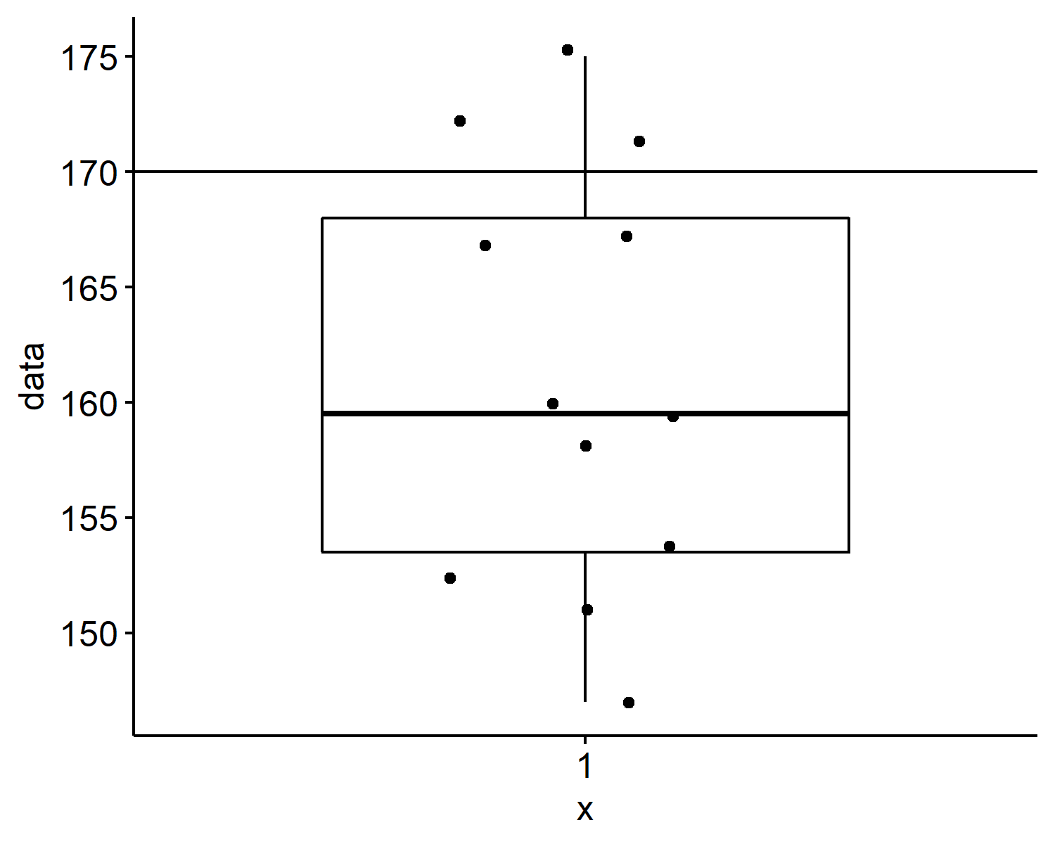 + iii 7 women and 8 men of height: 166, 189, 180, 193, 148, 174, 161, 170, 172, 179, 158, 157, 176, 171, 174

##   
## One Sample t-test  
##   
## data: data  
## t = 0.38726, df = 14, p-value = 0.7044  
## alternative hypothesis: true mean is not equal to 170  
## 95 percent confidence interval:  
## 164.554 177.846  
## sample estimates:  
## mean of x   
## 171.2

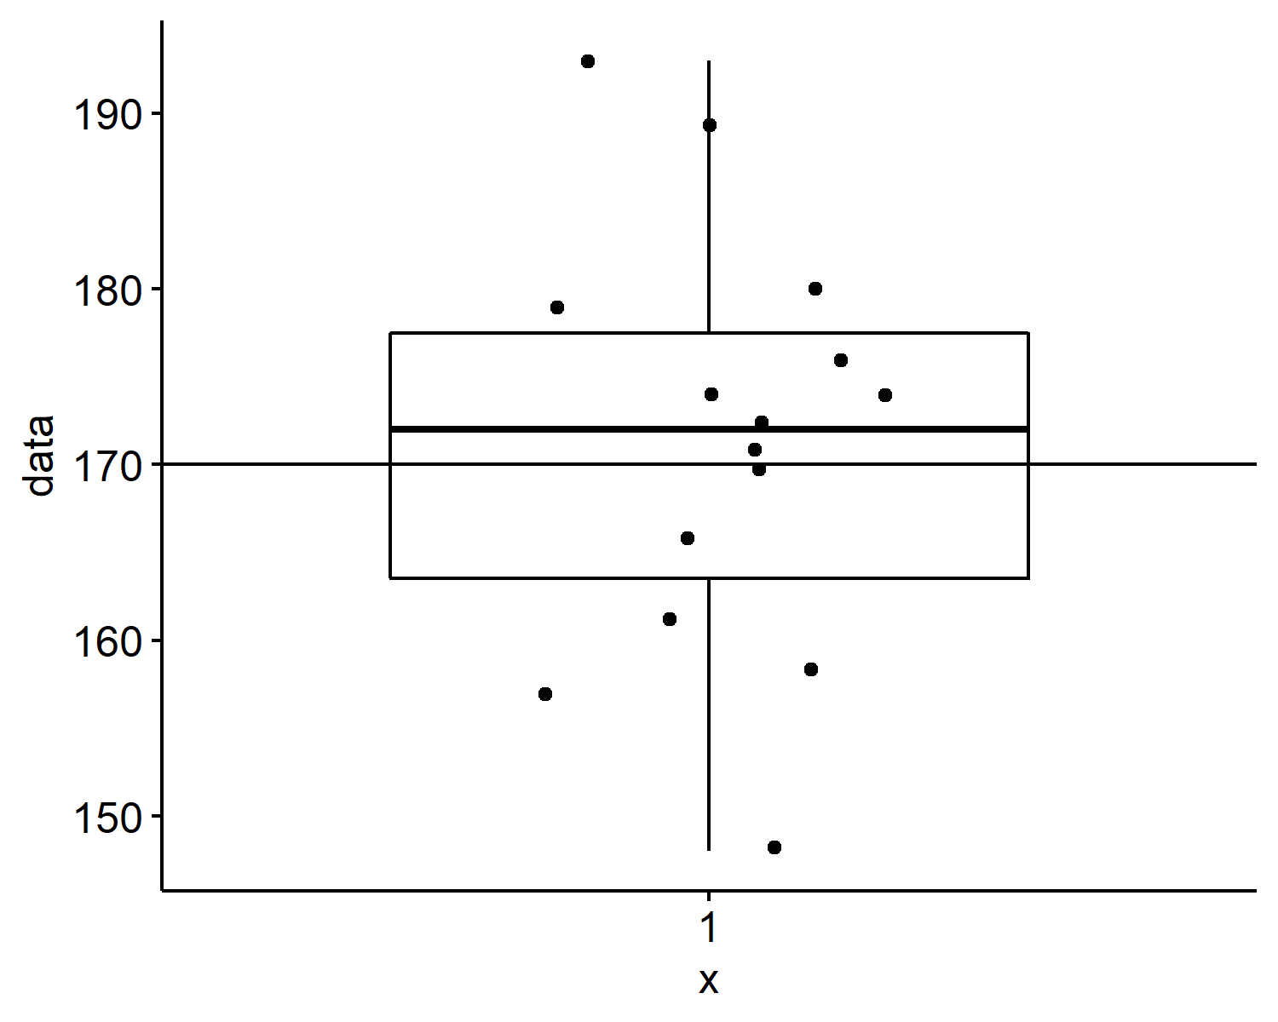

* iv Compare the height of the 10 men and the 12 women

##   
## Welch Two Sample t-test  
##   
## data: men and women  
## t = 4.1805, df = 15.766, p-value = 0.0007278  
## alternative hypothesis: true difference in means is not equal to 0  
## 95 percent confidence interval:  
## 10.10008 30.93325  
## sample estimates:  
## mean of x mean of y   
## 181.6000 161.0833

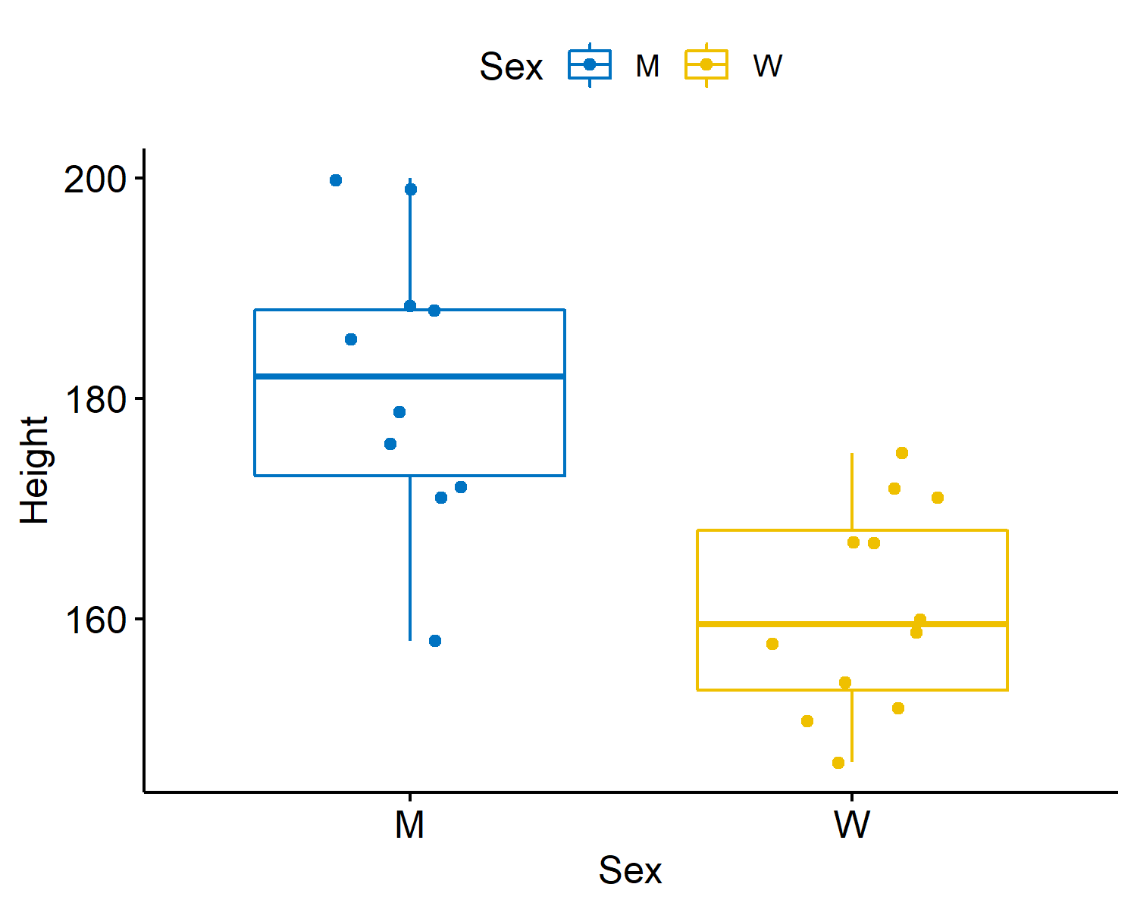

### QUESTION 2.

A survey claims that 8 out of 10 doctors recommend aspirin for their patients with headaches. To test this claim, a random sample of 100 doctors is obtained. Of these 95 doctors, 82 indicate that they recommend aspirin.

Calculate the z-test to test is the observed data different from the population data.

## [1] 1.538968

# t-test

### QUESTION 3

Read in the PearsonLeeSimple.csv data. Using an unpaired t-test compare:

* the heights of children and parents,
* within in the parents compared the Height of Mothers and Fathers.

##   
## Welch Two Sample t-test  
##   
## data: JB_PEARSON$parent and JB_PEARSON$child  
## t = -4.0421, df = 1480.7, p-value = 5.571e-05  
## alternative hypothesis: true difference in means is not equal to 0  
## 95 percent confidence interval:  
## -1.5384491 -0.5331326  
## sample estimates:  
## mean of x mean of y   
## 65.01247 66.04826

##   
## Welch Two Sample t-test  
##   
## data: JB_PEARSON$parent by JB_PEARSON$par  
## t = 14.124, df = 743.16, p-value < 2.2e-16  
## alternative hypothesis: true difference in means between group Father and group Mother is not equal to 0  
## 95 percent confidence interval:  
## 3.756744 4.969719  
## sample estimates:  
## mean in group Father mean in group Mother   
## 67.12390 62.76066

